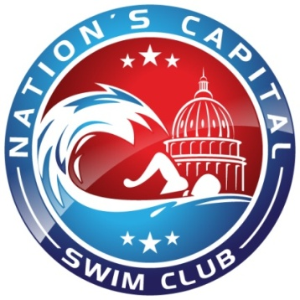
Nation’s Capital Swim Club
Standards:

The first goal is to earn your “Gold Team” patch. To do this the swimmer must legally compete in every event in their Age Group.

The second goal is to earn National Age Group Time Standards. After earning their “Gold Team” patch, swimmers who achieve time standards can earn “achievement“bars.

BB bar-achieve BB or faster times in at least 6 events

A bar- achieve A or faster times in at least 5 events

AA bar-achieve AA or faster times in at least 4 events

AAA bar-achieve AAA or faster times in at least 3 events

AAAA bar-achieve AAAA or faster times in at least 2 events

Bronze 1 and Bronze 2
Gold Patch Program
9-12 Year Olds

Swimmer’s Name _________________________________________

Age: ______ Birth date: ______________ Season_______________

 | Event Time and Date Achieved
Event | Patch | BB | A | AA | AAA | AAAA
50 Free
100 Free
200 Free
500 Free
50 Back
100 Back
50 Breast
100 Breast
50 Fly
100 Fly
100 IM
200 IM
200 BK, BR
or FLY (11&12’s Only)

Date Patch/Bar Earned

